**Fundamentals of Industry 4.0**

**PROJECT TITLE: Evaluating the strategies and selecting the best suitable strategy for implementing I4.0 in Industries with MCDM method (FAHP).**



**Submitted to**

**Dr. Surya Prakash**

**Submitted by**

1. **Lathish Kumar - 1700142C205**
2. **S. Sai Lokesh - 1700426C205**

**Table of Contents:**

|  |  |  |
| --- | --- | --- |
| **S. No** | **Topics** | **Pg.no** |
| **1** | **Introduction** | **3-4** |
| **2** | **Literature Review** | **5-6** |
| **3** | **Methodology** | **7-8** |
| **4** | **Numerical / Case Demonstration** | **9-18** |
| **5** | **Results** | **19-26** |
| **6** | **Discussion** | **26** |
| **7** | **References** | **27** |

**Introduction:**

As per current trend in all industries around the globe are mainly focusing on smart industries which implement industry I4.0. Many technologies are emerging in order to make the industry very smart. Many emerging new technologies that completely transform the industry into Digital areBig Data, Cloud Computing, Data Analysis, Automation, Augmented reality, Cyber security, IOT, IIOT etc. These technologies help to optimize the manufacturing process and also supply chain industries a making smart which leads to the Industry 4.0 era.

Many Frameworks had been developed likeRAMI Model, Singapore smart readiness index, Malaysian Industrial Frameworks etc. in order to standardize according to industry 4.0 norms from these Frameworks many industries are slowly changing their industry into smart factories and making intelligent manufacturing.And also, many companies IBM, CISCO also establish some frameworks which implement industry 4.0. Many standards or the set of rules or instructions are established in order to maintain the industry follow the same pattern uniquely and it is necessary to maintain some standards and specification in safety in the industry.

From these all new technologies,standards and different Frameworks which make the industry smarter this leads to motivate our project. The main aim of this project is to select the best strategies that contribute to industry 4.0. In Many strategies only few strategies are selected among them best strategies are chosen which implement industry i4.0. Some of these strategies have been selected from many papers.

As the scope of these emerging technologies increases, these lead to the companies to adopt industry 4.0 strategies that help them in the changing world to sustain in the business world. Also the customer centric approach of the companies makes them more competitive one in the global market. The strategies are theframeworks or the methodology approach that are selected which will be helpful while evaluating the current companies scenarios and the requirements for the industry 4.0implementation.

Some of the strategies have been studied in that strategies some strategies are taken into the picture. Industry4.0 transformation deeply affects human resource management due to its business environment. As per new trend in industry 4.0 employee skills, recruitment and training is very essential inorder to start any employee career in the industry trend . Many industries nowadays are automated or by robots so they require some operating model which would implement industry 4.0 so from this human resource management strategy is required. Information systems are necessary in order to make all the systems like machines, robots aligned centered. So, this information system strategy has been required as one of the strategies. It is very important to distribute the tasks in an industry properly by smart and innovative thinking and also designing the process of workflow correctly so this strategy work organization and design-oriented strategy isrequired.

Resources and standardizations are also required because they are the sources you should take some reference or framework or model in implementing i4.0 and standards are taken to follow the same pattern to maintain safety in the industry so this strategyResources and standardization is required. The new business model involves some value creation than older ones. Some of these models become digital which leads to one of the strategies required to implement industry 4.0. As operation management involves troubleshooting the problem easily, it also helps them to identify the errors and also involves greater risk so operation and optimization is required for one of the strategies. In order to exchange the information from one system to another system in an industry or to integrate systems this interoperability strategy is required.

To reduce the complexity of the big problem by modularity we are able to solve the problems easily by modularity strategy. As it divides the complex problem into blocks of information. So, this modularity strategy is required to implement industry 4.0. Data is collected which may further be required to analyze the data if any vibration in the machine occurs so this data is been collected and analyzed so this real time strategy is required for the strategy. Service Oriented strategy is a marketing tool of which business analysts work of it they deliver customised product.

In correct time so these strategies are studied from literature review and are also done as further below.

**Literature Review:**

As from the past there is less research done in implementing industry 4.0 techniques and prioritizing the strategies. Some research papers are studied in order to understand the strategies which are implemented in industry 4.0 like Schumacher mainly used 9 dimensions & 62 attributes basically used to examine the maturity of Industry 4.0 model. (9 dimensions are product, customers, operation, technology, leadership, policy, culture and employees used). Saturno who is the first to analyze interoperability between system and machines in industry 4.0.

Moktadir.in the year of 2018 he mainly focused on only one criteria of manufacturing operation in Bangladesh leather industry by best- worst-method. They mainly gave reasons for the drawbacks of implementing I4.0 is technological infrastructure is the main drawback in implementing I4.0. From his study various strategies have been taken for our study. Longo (2019) suggested that training of employees could result in high performance in factories. Research by Luthra and Mangla (2018) had examined 18 challenges of industry 4.0 in the supply chain by the A.H.P. method

As many real problems do not have a single attribute for optimum decision making. Implementing industry 4.0 by multi criteria decision making since multi attributes exist. Hannan Amoozad Mahdi Raji focused on prioritizing strategies which implement industry I4.0 by hybrid model of best worst method and T.O.D.I.M-I.V.I. F. Interval Valued Intuitionistic Fuzzy (I.V.I.F.S) is a suitable tool to determine membership and non-membership in closed intervals. TODIM is the new method ranking is done on alternatives by paring comparisons. B.V.M(Best worst method) is also the new and best method done on paired comparison weighing method. The results from weighting the attributes for implementing the industry 4.0 indicated that Tech, Quality inspection and operations etc have the higher importance. Multi criteria decision making is used in selecting the appropriate strategies. This paper is about the combination of both best worst method and T.O.D.I.M method and bringing balance to automation, attributes for assessing the strategy of implementing industry 4.0.

Goreckly has implemented a virtual training system VISTRA leading automotive industry because these industries are adopting technologies like cyber physical systems and IOT (Internet of things). They used the A.P.C method which is known as Autonomous production control as this control involved in job shop manufacturing integrates all the tasks like capacity control, order release etc.

Melike Erdogan, they mainly focused on best strategy in implementation of industry 4.0 by multi criteria decision making by integration of fuzzy A.H.P and VIKOR technologies. A.H.P is also with this model. We are able to simplify the complex problem into elements and are used to determine the weights of the criteria. VIKOR was developed by Ogrizovic and Tzeng this method mainly focuses on the rank alternatives and determines the compromise solution to ideal. The most important criteria in decision making is leadership and the last alternative was found to be developing new business models.

From these papers we took some strategies that implement industry 4.0 and lead the industry into smart factory they are Human Resource Management Strategy, Improving Information Systems Strategy, Work Organization & design oriented strategy, Resources & Standardization strategy, New business models development strategy, Operations & optimization strategy, Interoperability Strategy, Modularity Strategy, Real-time capability Strategy and Service-orientation Strategy and also from this strategies the best strategy is selected from the method F.A.H.P method.

**Methodology:**

As the Industry 4.0 technologies and strategies are increasing these days, most of the companies are trying to implement the industry 4.0 strategies that are present now. For that most of the companies had developed different strategies for implementing Industry 4.0. As discussed in the literature section most of the top emerging companies nowadays are contributing more in the fourth industrial revolution. In this project we selected, top 10 strategies which will be prioritized at first when a company wants to implement industry 4.0 technologies in it. Also, for selecting the strategies in Industry 4.0 there are different types of attributes which a company needs to consider before taking into consideration the industry 4.0 implementation. In this, we took 12 keen attributes for evaluating the strategies.

The methodology that we select for evaluating these strategies is a MCDM (Multi Criteria Decision Making) tool called FAHP (Fuzzy Analytical Hierarchy Process).

**FAHP**:

**FAHP** stands for Fuzzy Analytic Hierarchy Process and it belongs to the Multi-Criteria Decision-Making methods (MCDM). In FAHP, the values like price, weight, or area, or even subjective opinions such as feelings, preferences, or satisfaction, can be translated into measurable numeric relations and the method gives huge importance for the data from the decision-makers. Also, the FAHP is different from the AHP, because of its fuzzified relative importance, where the relative importance of the criteria are marked in the form of intervals rather than a certain number in the pairwise comparison matrix.

In the FAHP, the relative importance scale for the criteria’s are marked using the Triangular Fuzzy number, which represents the criteria based on other criteria in the form of (a,b,c) where a is the lower limit , b is the middle one based on AHP relative importance scale and the c is the upper limit .

For inverse values, it is solved using (a,b,c)-1 = (1/c,1/b,1/a)

‘



|  |  |  |
| --- | --- | --- |
| Relative importance (Co) | Definition | Triangular Fuzzy number |
| 1 | Equal importance | (1,1,2) |
| 2 | Middle value between 1 and 3 | (1,2,3) |
| 3 | Weak importance | (2,3,4) |
| 4 | Middle value between 3 and 5 | (3,4,5) |
| 5 | Strong Importance | (4,5,6) |
| 6 | Middle value between 5 and 7 | (5,6,7) |
| 7 | Very strong importance | (6,7,8) |
| 8 | Middle value of 7 and 9 | (7,8,9) |
| 9 | Absolute importance | (8,9,9) |

Table 1: Fuzzy Relative Importance Scale based on Triangular Fuzzy Number.

**Strategies evaluated using FAHP where multi-criteria decision making is required:**

The strategies that are selected for the project are Human Resource Management Strategy, Improving Information Systems Strategy, Work Organization & design-oriented strategy, Resources & Standardization strategy, New business models development strategy, Operations & optimization strategy, Interoperability Strategy, Modularity Strategy, Real-time capability Strategy and Service-orientation Strategy.

The attributes that we selected are Leadership, customer, product, operation, culture, staff, technology, organization, Quality, Governance, Inventory and Maintenance.

**Solving Approach using FAHP:**

For the decision making, we selected a **Plastic Parts Manufacturing Industry** and applied decision making according to the current situations in that industry and attributes also evaluated using the same approach.

**Step-1**: To develop a hierarchical structure with a goal at the top level, the attributes / criteria at the second level and the alternatives at the third level. Here,

**Goal:**  Selecting the best strategy for implementing Industry 4.0.

**Criteria:** Human Resource Management Strategy, Improving Information Systems Strategy, Work Organization & design-oriented strategy, Resources & Standardization strategy, New business models development strategy, Operations & optimization strategy, Interoperability Strategy, Modularity Strategy, Real-time capability Strategy and Service-orientation Strategy

**Alternatives:** Leadership, customer, product, operation, culture, staff, technology, organization, Quality, Governance, Inventory and Maintenance.

The Hierarchical Structure of it is:

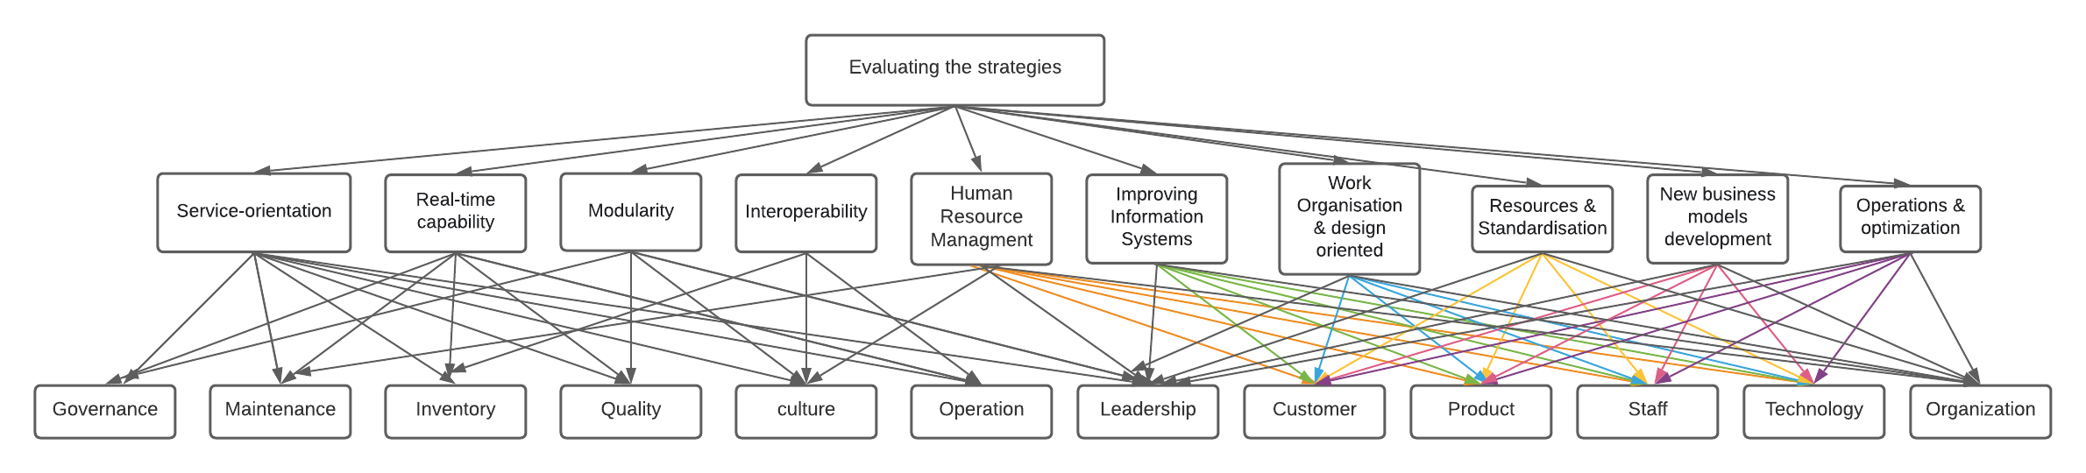

Fig.1: Hierarchical Structure of decision making for evaluating the strategies.

**Step-2:**

To determine the relative importance of the different attributes or criteria with respect to the goal (Pairwise comparison matrix).

The pairwise comparison matrix is written based on the relative importance of the criteria’s.

For example, if we are comparing the human resource management and improving information systems criteria of the goal, the relative importance of the criteria is considered and based upon the fuzzy relative importance scale the value is noted in the table. For the inverse of the matrix calculation, the below formula is used.

|  |  |  |  |  |  |  |  |  |  |  |  |
| --- | --- | --- | --- | --- | --- | --- | --- | --- | --- | --- | --- |
| Human Resource Management Strategy | | | Improving Information Systems Strategy | | | Work Organisation & design oriented strategy | | | Resources & Standardisation strategy | | |
| Lower | Middle | Upper | Lower | Middle | Upper | Lower | Middle | Upper | Lower | Middle | Upper |
| 1 | 1 | 2 | 4 | 5 | 6 | 2 | 3 | 4 | 1 | 2 | 3 |
| 0.16667 | 0.2 | 0.25 | 1 | 1 | 2 | 1 | 2 | 3 | 4 | 5 | 6 |
| 0.25 | 0.333 | 0.5 | 0.333 | 0.5 | 1 | 1 | 1 | 2 | 0.333 | 0.5 | 1 |
| 0.333 | 0.5 | 1 | 0.16667 | 0.2 | 0.25 | 1 | 2 | 3 | 1 | 1 | 2 |
| 1 | 2 | 3 | 0.125 | 0.1428 | 0.16667 | 0.2 | 0.25 | 0.333 | 2 | 3 | 4 |
| 4 | 5 | 6 | 0.1428 | 0.16667 | 0.2 | 2 | 3 | 4 | 0.1428 | 0.16667 | 0.2 |
| 3 | 4 | 5 | 2 | 3 | 4 | 0.333 | 0.5 | 1 | 0.2 | 0.25 | 0.333 |
| 1 | 2 | 3 | 0.16667 | 0.2 | 0.25 | 4 | 5 | 6 | 0.1112 | 0.125 | 0.1428 |
| 0.125 | 0.1428 | 0.16667 | 7 | 8 | 9 | 0.2 | 0.25 | 0.333 | 0.333 | 0.5 | 1 |
| 0.1428 | 0.16667 | 0.2 | 0.25 | 0.333 | 0.5 | 0.1112 | 0.125 | 0.1428 | 4 | 5 | 6 |

|  |  |  |  |  |  |  |  |  |  |  |  |
| --- | --- | --- | --- | --- | --- | --- | --- | --- | --- | --- | --- |
| New business models development strategy | | | Operations & optimization strategy | | | Interoperability Strategy | | | Modularity Strategy | | |
| Lower | Middle | Upper | Lower | Middle | Upper | Lower | Middle | Upper | Lower | Middle | Upper |
| 0.333 | 0.5 | 1 | 0.16667 | 0.2 | 0.25 | 0.2 | 0.25 | 0.333 | 0.333 | 0.5 | 1 |
| 6 | 7 | 8 | 5 | 6 | 7 | 0.25 | 0.333 | 0.5 | 4 | 5 | 6 |
| 3 | 4 | 5 | 0.25 | 0.333 | 0.5 | 1 | 2 | 3 | 0.16667 | 0.2 | 0.25 |
| 0.25 | 0.333 | 0.5 | 5 | 6 | 7 | 3 | 4 | 5 | 7 | 8 | 9 |
| 1 | 1 | 2 | 0.16667 | 0.2 | 0.25 | 0.25 | 0.333 | 0.5 | 0.1112 | 0.1112 | 0.125 |
| 4 | 5 | 6 | 1 | 1 | 2 | 0.333 | 0.5 | 1 | 0.125 | 0.1428 | 0.16667 |
| 2 | 3 | 4 | 1 | 2 | 3 | 1 | 1 | 2 | 5 | 6 | 7 |
| 8 | 9 | 9 | 6 | 7 | 8 | 0.1428 | 0.16667 | 0.2 | 1 | 1 | 2 |
| 0.25 | 0.333 | 0.5 | 0.25 | 0.333 | 0.5 | 0.1112 | 0.125 | 0.1428 | 0.25 | 0.333 | 0.5 |
| 0.125 | 0.1428 | 0.16667 | 0.1428 | 0.16667 | 0.2 | 0.333 | 0.5 | 1 | 0.1112 | 0.125 | 0.1428 |

|  |  |  |  |  |  |
| --- | --- | --- | --- | --- | --- |
| Real-time capability Strategy | | | Service-orientation Strategy | | |
| Lower | Middle | Upper | Lower | Middle | Upper |
| 6 | 7 | 8 | 5 | 6 | 7 |
| 0.125 | 0.125 | 0.1428 | 2 | 3 | 4 |
| 3 | 4 | 5 | 7 | 8 | 9 |
| 1 | 2 | 3 | 0.16667 | 0.2 | 0.25 |
| 2 | 3 | 4 | 6 | 7 | 8 |
| 2 | 3 | 4 | 5 | 6 | 7 |
| 7 | 8 | 9 | 1 | 2 | 3 |
| 2 | 3 | 4 | 7 | 8 | 9 |
| 1 | 1 | 2 | 3 | 4 | 5 |
| 0.2 | 0.25 | 0.333 | 1 | 1 | 2 |

Table 2: Pairwise comparison matrix of all 10 strategies

**Step -3**: To calculate the Fuzzified Pairwise Comparison matrix. In which the fuzzy weights of the criteria’s are calculated with the help of geometric mean(ri).

(This method was proposed by Buckley in 1985).

The equation for the geometric mean calculation for two fuzzy numbers is:

A1 x A2 = (l1, m1, u1) x (l2, m2, u2) = (l1 * l2, m1 *m2, u1 * u2)

Like mentioned in the above equation, the fuzzy geometric mean (ri) is calculated for 10 fuzzy numbers as.

For Human Resource/ Information systems is:

ri = ((1*4*2*2*6*8)^(1/10)﻿,(1*5*3*3*7*9)^(1/10),(2*6*4*4*8*9)^(1/10))

Lower Middle Upper

In the same way, ri for all the criteria’s are calculated.

For the Fuzzy weights (Wi), the below formula is used to calculate:

Wi = ri x (r1 + r2 + ……..+rn)-1

|  |  |  |  |  |  |
| --- | --- | --- | --- | --- | --- |
| Fuzzy Geometric Mean(Ri) | | | Fuzzy Weights (Wi) | | |
| Lower | Middle | Upper | Lower | Middle | Upper |
| 0.9880950 | 1.3174315 | 1.9173150 | 0.0636814 | 0.1177583 | 0.2239680 |
| 1.1746213 | 1.4858415 | 1.9662286 | 0.0757028 | 0.1328116 | 0.2296817 |
| 0.7694788 | 1.0356425 | 1.5581935 | 0.0495919 | 0.0925707 | 0.1820178 |
| 0.8680182 | 1.1772902 | 1.6781984 | 0.0559426 | 0.1052318 | 0.1960360 |
| 0.5551436 | 0.7116423 | 0.9601704 | 0.0357783 | 0.0636100 | 0.1121607 |
| 0.8778010 | 1.1035060 | 1.4895216 | 0.0565731 | 0.0986366 | 0.1739960 |
| 1.3953153 | 1.9663072 | 2.8055288 | 0.0899262 | 0.1757579 | 0.3277232 |
| 1.2167797 | 1.5133345 | 1.9158591 | 0.0784198 | 0.1352691 | 0.2237979 |
| 0.4448902 | 0.5522085 | 0.7852686 | 0.0286726 | 0.0493590 | 0.0917298 |
| 0.2705235 | 0.3243835 | 0.4399435 | 0.0174349 | 0.0289949 | 0.0513913 |

Table 3: Fuzzy Geometric mean (Ri) and Fuzzy weights (Wi)

For the Wi, as mentioned in the above formula, the summation of the geometric mean is to be done. For that the sum of the lower, middle and upper limits of the fuzzy geometric means are added in the below table. And for the inverse of the fuzzy number the (a, b, c)-1 = (1/c,1/b,1/a) is used.

Then the inverse sum of the geometric mean is multiplied with the geometric mean, to calculate the fuzzy weights (Wi) for the criteria.

|  |  |  |  |
| --- | --- | --- | --- |
| SUM | 8.5606667 | 11.1875877 | 15.5162274 |
| Inverse | 0.0644486557 | 0.08938477419 | 0.1168133325 |

Table 4: Sum and inverse of geometric means

**Step-4:** To calculate the Normalized Weights:

For the Normalized weights calculation, the average of the fuzzy weights is used. Here, it is the Centre Of Area (COA) is used.

Centre Of Area (COA) = (l + m + u)/3

After the average weights, the sum of the weights of all the criteria are calculated. If the sum is more than 1. Then divide each weight of the criteria by the sum to make the weights normalized.

Therefore, the normalized weights of the criteria are:

|  |  |
| --- | --- |
| Centre Of Area (Weights) | Normalized Weights |
|
| 0.1460653596 | 0.1480983542 |
| 0.1080601036 | 0.1095641263 |
| 0.1190701267 | 0.1207273912 |
| 0.07051631595 | 0.07149778955 |
| 0.1097352342 | 0.111262572 |
| 0.1978024291 | 0.2005555205 |
| 0.1458289222 | 0.1478586261 |
| 0.05658715044 | 0.05737475248 |
| 0.03260703035 | 0.03306086772 |
| 0.9862726721 | 1 |

Table 5: Centre of Area (weights) & Normalized weights

**Step-5**: In the same way, to calculate the normalized weights for the 12 alternatives using FAHP. The results (normalized weights) of considering the alternatives based on the criteria are:

For each criteria, the alternatives are compared using FAHP, and the resulting normalized weights are taken into consideration.

1. Criteria: Human Resource Management Strategy, Improving Information Systems Strategy

Alternatives: Leadership, customer, product, operation, culture, staff, technology, organization, Quality, Governance, Inventory and Maintenance

The normalized weights are:

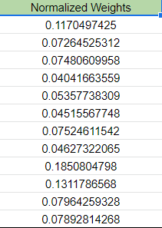 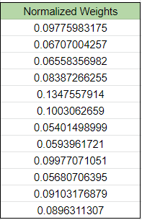

Table 6.1: Normalized weights of Human Resource Management Strategy, Improving Information Systems Strategy

2.Criteria: Work Organization & design-oriented strategy, Resources & Standardization strategy.

Alternatives: Leadership, customer, product, operation, culture, staff, technology, organization, Quality, Governance, Inventory and Maintenance

The normalized weights are:

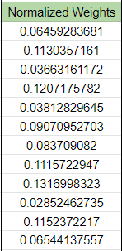 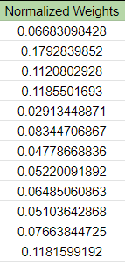

Table 6.2: Normalized weights of Work Organization & design-oriented strategy, Resources & Standardization strategy.

3.Criteria: New business models development strategy, Operations & optimization strategy.

Alternatives: Leadership, customer, product, operation, culture, staff, technology, organization, Quality, Governance, Inventory and Maintenance

The normalized weights are:

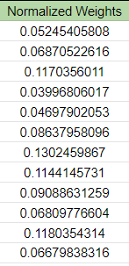 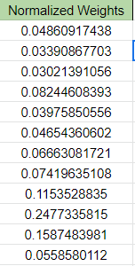

Table 6.3: Normalized weights of New business models development strategy, Operations & optimization strategy.

4.Criteria: Interoperability Strategy, Modularity Strategy.

Alternatives: Leadership, customer, product, operation, culture, staff, technology, organization, Quality, Governance, Inventory and Maintenance

The normalized weights are:

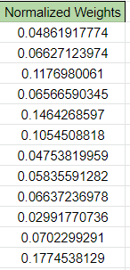 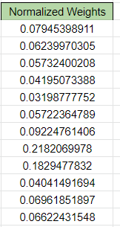

Table 6.4: Normalized weights of Interoperability Strategy, Modularity Strategy

5.Criteria: Real-time capability Strategy, Service-orientation Strategy.

Alternatives: Leadership, customer, product, operation, culture, staff, technology, organization, Quality, Governance, Inventory and Maintenance

The normalized weights are:

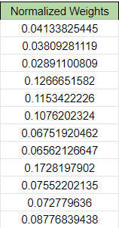 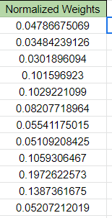

Table 6.5: Normalized weights of Real time Capability strategy & Service Orientation strategy.

**Step- 6**: On comparing the results (normalized weights) from the criteria and alternatives, the resultant table is:

In the below table, the criteria weights and the alternatives weights are taken and are compared with each alternative according to the criteria.

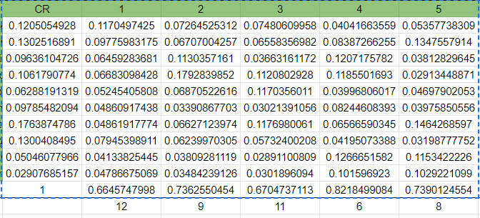

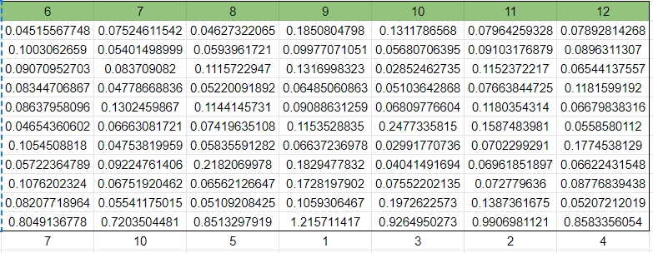

Table 7: Criteria weights and the alternatives weights are taken and are compared with each alternative according to the criteria.

From the total of the weights, the ranking of the alternatives of the criteria is found based on the values from maximum to minimum.

|  |  |
| --- | --- |
| Leadership | 12 |
| Customer | 9 |
| Product | 11 |
| Operation | 6 |
| Culture | 8 |
| Staff | 7 |
| Technology | 10 |
| Organization | 5 |
| Quality | 1 |
| Governance | 3 |
| Inventory | 2 |
| Maintenance | 4 |

Table 8: Ranking of the alternatives of the criteria’s

The radar chart of the alternatives is: 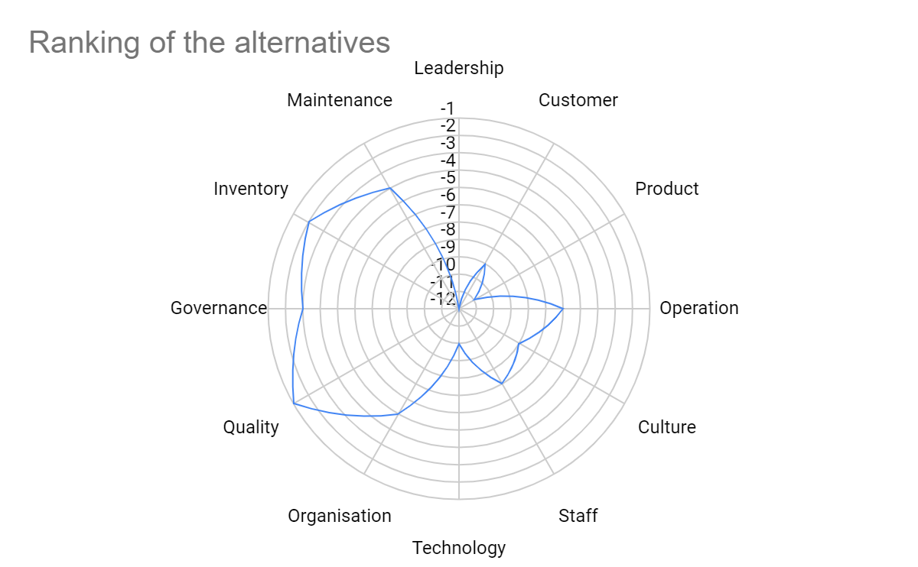

Fig 2: Radar Chart of the Alternatives

**AHP:**

Also, for selecting the best criteria, we need to focus on the AHP method.

|  |  |  |  |  |  |  |  |  |  |  |
| --- | --- | --- | --- | --- | --- | --- | --- | --- | --- | --- |
| Strategies | Human Resource Management Strategy | Improving Information Systems Strategy | Work Organisation & design oriented strategy | Resources & Standardisation strategy | New business models development strategy | Operations & optimization strategy | Interoperability Strategy | Modularity Strategy | Real-time capability Strategy | Service-orientation Strategy |
| Human Resource Management Strategy | 1 | 5 | 3 | 2 | 1/2 | 1/5 | 1/4 | 1/2 | 7 | 6 |
| Improving Information Systems Strategy | 1/5 | 1 | 2 | 5 | 7 | 6 | 1/3 | 5 | 1/8 | 3 |
| Work Organisation & design oriented strategy | 1/3 | 1/2 | 1 | 1/2 | 4 | 1/3 | 2 | 1/5 | 4 | 8 |
| Resources & Standardisation strategy | 1/2 | 1/5 | 2 | 1 | 1/3 | 6 | 4 | 8 | 2 | 1/5 |
| New business models development strategy | 2 | 1/7 | 1/4 | 3 | 1 | 1/5 | 1/3 | 1/9 | 3 | 7 |
| Operations & optimization strategy | 5 | 1/6 | 3 | 1/6 | 5 | 1 | 1/2 | 1/7 | 3 | 6 |
| Interoperability Strategy | 4 | 3 | 1/2 | 1/4 | 3 | 2 | 1 | 6 | 8 | 2 |
| Modularity Strategy | 2 | 1/5 | 5 | 1/8 | 9 | 7 | 1/6 | 1 | 3 | 8 |
| Real-time capability Strategy | 1/7 | 8 | 1/4 | 1/2 | 1/3 | 1/3 | 1/8 | 1/3 | 1 | 4 |
| Service-orientation Strategy | 1/6 | 1/3 | 1/8 | 5 | 1/7 | 1/6 | 1/2 | 1/8 | 1/4 | 1 |

Table 9: pairwise comparison matrix with the sum of the columns along with it.

|  |  |  |
| --- | --- | --- |
| Weighted Sum Values | Critical Weights | Ratio (WSV/CW) |
| 0.1007801693 | 0.1055485749 | 0.9548226433 |
| 0.138192736 | 0.1298040241 | 1.064625977 |
| 0.07081192622 | 0.08129074879 | 0.8710945252 |
| 0.1630510215 | 0.1362630676 | 1.196589982 |
| 0.06070201334 | 0.06571148617 | 0.9237656441 |
| 0.08642290017 | 0.1016909271 | 0.8498585133 |
| 0.1398587756 | 0.1339072935 | 1.044444793 |
| 0.1126560284 | 0.1375896275 | 0.818782858 |
| 0.07403836479 | 0.0658667645 | 1.124062573 |
| 0.05348606468 | 0.04232748578 | 1.263624893 |

Table 10: The critical weights, weighted sum values and ratio of the criteria.

|  |  |
| --- | --- |
| Random Index | No.of Compared Elements (n) |
| 1.49 | 10 |

|  |  |
| --- | --- |
| Lambda (Max) | 10.615 |
| Consistency Index (CI) | 0.998751 |
|  |  |
| Consistency Ratio (CR) | 0.06710 |

Table 11: CI, RI and CR of the criteria are calculated.

As the CR < 0.10. Therefore, the matrix is consistent and helpful in decision making

The ranking table of the critical weights of the criteria are:

|  |  |  |
| --- | --- | --- |
| Normalized Weights | Percentage | Ranking |
| 0.1055485749 | 10.55485749 | 5 |
| 0.1298040241 | 12.98040241 | 4 |
| 0.08129074879 | 8.129074879 | 7 |
| 0.1362630676 | 13.62630676 | 2 |
| 0.06571148617 | 6.571148617 | 9 |
| 0.1016909271 | 10.16909271 | 6 |
| 0.1339072935 | 13.39072935 | 3 |
| 0.1375896275 | 13.75896275 | 1 |
| 0.0658667645 | 6.58667645 | 8 |
| 0.04232748578 | 4.232748578 | 10 |

Table 12: Normalized weights, Percentage & Ranking

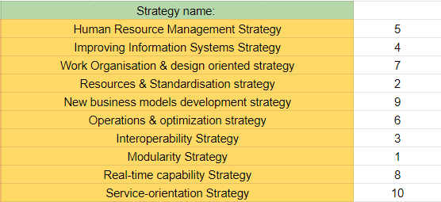

Table 13: Ranking of strategies

The radar chart of the criteria’s is:

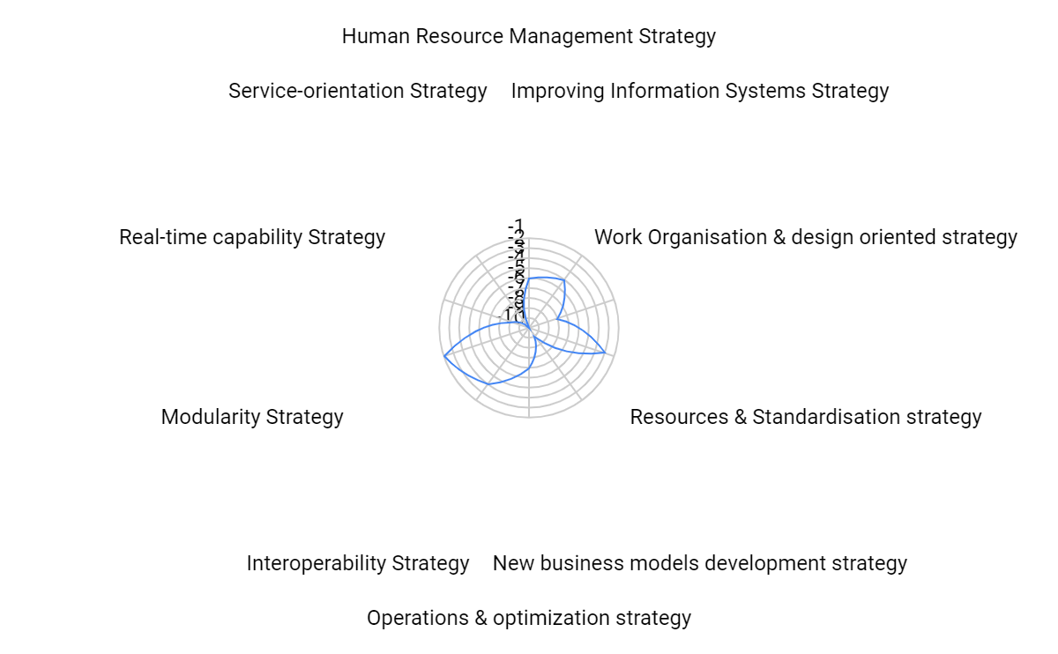

Fig 3: Radar chart of criteria’s

Based on the above radar chart, **modularity** is the most important criteria according to AHP for decision making on selecting the best strategy for industry 4.0 implementation.

Discussions:

From the above application of FAHP it is clearly visible that the strategies that an industry needs to implement according to the above-mentioned criteria and attributes are purely dependent on the decision maker himself. But this way of approach helps the decision maker to solve the problem predominantly and accurately selecting which strategy is needed for the industry to implement at the right time.

From the above evaluating approach, it is found that Quality is the important attribute and Modularity is the important according to the method as the decision maker gives them more preference most of the time. So, they are ranked one in the radar chart from the solving. So, from numerical solving, it is clearly found that for the Plastic manufacturing Industry, Quality must be the first priority to consider for sustainability in this global competitive market. Also, the Industry needs to select the modularity strategy for the upcoming of the industry growth.

Also in FAHP, as the number of the criteria elements are increasing (n is increasing) this leads to the increase in the decision making pairwise comparison matrix columns which on calculating gives the fuzzified matrices at the values in the intervals of 0 and 1. Evaluating the strategies and attributes based on these criteria weights with values rounded up to four zeros after the decimal is not defined as a best approach. As the values are less numbers, so at least 6-7 zeros after the decimal point need to be considered for the effective evaluation of the criteria. Also, the increasing criteria leads to computerized data analysis as we cannot solve them accurately and precisely while the criteria are more than 10.

Also, there are other strategies like virtualization, Decentralization, German Industry Strategy Framework and US strategy evaluating tools etc. which also an Industry can consider during its Industry 4.0 implementation strategies evaluation time. Also, the FAHP approach is the effective and easily understood approach for beginners for Multi Criteria Decision Making of the standards, strategies and frameworks in Industry 4.0.

**References:**

1. **Evaluating Strategies in implementing i4.0: using the approach of B.W.M. and fuzzy T.O.D.I.M.** Hannan Amoozad Mahdiraji,Edmundas Kazimieras Zavadskas,
2. **Selecting The suitable strategy for i4.0 With a Case Study** MelikeErdogan, BetulOzkan, Ali Karacan and IhsanKaya
3. **Influences Of the I4.0 on Revolution on the income Development and Consumer behaving: A Systematic Review** Violeta Sima, Ileana Georgiana Gheorghe ,Jonel Subi´c and Dumitru Nancu
4. Kagermann,Henning, Reiner Anderl, JürgenGausemeier, Günther Schuh, and Wolfgang Wahlster.2016. *I****ndustrie 4.0 in a Global Context***
5. Rodríguez, Antonio. 2017. **An Integrated TOPSIS, FAHP.**